**CANKAYA UNIVERSITY**

**FACULTY OF ENGINEERING**

**COMPUTER ENGINEERING DEPARTMENT**

****

**CENG 407  
Innovative System Design and Development I**

**PROJECT MANAGEMENT ASSISTANT**

***Hakan İREN 201411211***

***Selçuk ATAGÜN 201411204***

***Advisor: Prof. Dr. Erdoğan DOĞDU***

**Word Count: 7291**

Contents

[1. LITARATURE ABSTRACT 3](#_Toc484397770)

[1.1. What is a Project Management System? 4](#_Toc484397771)

[1.2. Key Features of the Project Management Assistant 4](#_Toc484397772)

[1.1.1. Project Start 4](#_Toc484397773)

[1.1.2. Planning of the project 4](#_Toc484397774)

[1.1.3. Project follow-up and control 4](#_Toc484397775)

[1.1.4. Completion of the project 4](#_Toc484397776)

[1.3. PMA Benefits 5](#_Toc484397777)

[1.4. General System Architecture 6](#_Toc484397778)

[1.5. Module Dependencies 6](#_Toc484397779)

[1.6. Related Application 7](#_Toc484397780)

[1.7. System Overview 10](#_Toc484397781)

[2. SRS PREFACE 13](#_Toc484397782)

[1.2. Introduction 14](#_Toc484397783)

[1.2.1. Purpose 14](#_Toc484397784)

[1.2.2. Scope 14](#_Toc484397785)

[1.2.3. Definitions, Acronyms & Abbreviations 15](#_Toc484397786)

[1.3. Overall Description 17](#_Toc484397787)

[1.3.2. System Interface 17](#_Toc484397788)

[1.3.3. User Interfaces 17](#_Toc484397789)

[1.3.4. Admin 18](#_Toc484397790)

[1.3.5. Project Manager 18](#_Toc484397791)

[1.3.6. Team Member (Staff) 18](#_Toc484397792)

[1.3.7. Hardware Interfaces 18](#_Toc484397793)

[1.3.8. Software Interfaces 18](#_Toc484397794)

[1.3.9. Communication Interfaces 18](#_Toc484397795)

[1.3.10. Memory Constraints 18](#_Toc484397796)

[1.3.11. Assumptions and Dependencies 24](#_Toc484397797)

[1.4. Specific Requirements 25](#_Toc484397798)

[1.5. Performance Requirements 32](#_Toc484397799)

[1.6. Logical Database Requirements 32](#_Toc484397800)

[1.7. Software System Attributes 32](#_Toc484397801)

[1.8. Gamification 34](#_Toc484397802)

[1.9. Appendices 35](#_Toc484397803)

[3. SDD PREFACE 44](#_Toc484397804)

[1.10. INTRODUCTION 45](#_Toc484397805)

[1.11. SYSTEM OVERVIEW 48](#_Toc484397806)

[1.12. SYSTEM COMPONENTS 49](#_Toc484397807)

[1.13. DETAILED DESIGN 79](#_Toc484397808)

# **LITARATURE ABSTRACT**

In this literature review, we present literature related to our Project Management System project. We will first introduce Project Management Systems (PMS). Secondly, we explain why the project management system should be used, its logic, properties, types and advantages. Due to PMS, even those who do not have high-level computer usage information without code knowledge can take tasks in important projects, undertake project follow-up and report projects. In addition, the system is based on web technologies, that for reason we can easily access the system anywhere in the world. In this literature, we will explain similar systems and what is used differently than these systems.

## **What is a Project Management System?**

The project management system is used to manage the project. Project management system is the planning, reporting and control of project activities to reach the project objectives. When these activities are carried out, it is necessary to stay within performance, cost, time limits and to keep project size within acceptable limits. Project management provides us installation, using, management and simple features make simple use without technical knowledge. [4]

The project management system we will do prosvide both of a single user and common users that collaborative system. A single user system is programmed with the assumption that one person will make changes at the same time in the project plan. Also common users can programmed project at the same time.

## **Key Features of the Project Management Assistant**

### **Project Start**

The starting part of the project is very important because if this step does not start correctly, the other steps will also be adversely affected. The PMA guides the user in the right way for the correct steps to be taken when starting the project and for the planning phase.

### **Planning of the project**

Errors in the planning phase will cause major obstacles to the success of the project, such as the start-up phase. For this reason, the PMA provides that important phase is done correctly by choosing who should be involved in the project, the role choices of the people involved in the project, and topics.

### **Project follow-up and control**

The control and observation phase consists of timely recognition of problems in the implementation of the project and timely corrective actions and procedures to control implementation. An important benefit of this phase is the difference in implementation from the project management plan through the monitoring and measurement of project performance.

### **Completion of the project**

It includes formal completion of the project. Administrative activities include archiving the files and documenting the lessons learned.

## **PMA Benefits**

* Easy reach to personal &projects information
* It offers objective tracking.
* Reducing paperwork
* It makes anyone a quick study.
* Easy communication between team members.

Besides these, there are many advantages of PMA web-based. These;

* Access to any type of computer without the need to install software on the user's computer
* Convenience in access control
* Single and multi-user
* One version and software to be maintained
* Central data warehouse
* Project information cannot be accessed when the user (or server) is offline.[3]

## **General System Architecture**

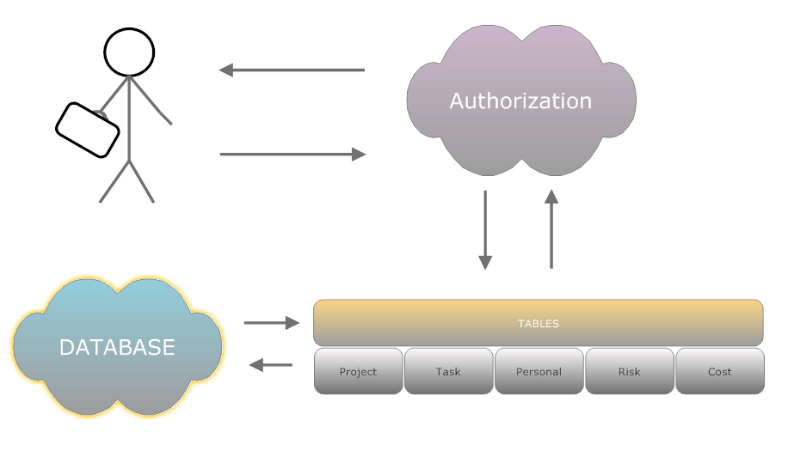**Figure-1:** System Architecture

## **Module Dependencies**

**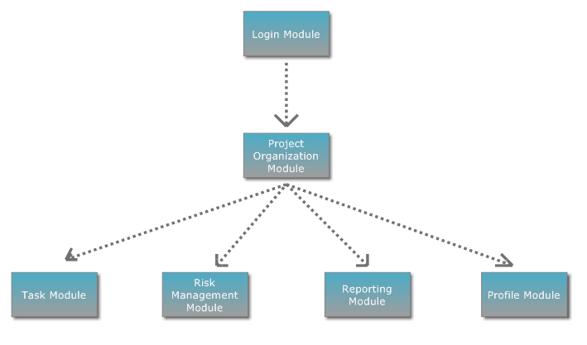**  
**Figure-2:** Module Dependencies

## **Related Application**

Redmine [1], Redmine is a web-based project management and bug tracking system software that is widely used all over the world. First released in 2006, Redmine is a free software that is an important part of the development infrastructure of tens of thousands of progenies in different sectors, especially computer software projects.

One of the most important features that distinguish Redmine from similar vehicles is that it offers extensive privatization possibilities. With Redmine, you can define and customize project-specific areas that have important functions in project management such as business records, business processes, user roles, wikis, and discussion areas

SebaPLUS [2] refers to Semantic e-Business applications, which enable you to manage all your activities that are important for carrying out your business through a single web-based system. You can use your company's internal activities and outgoing relationships in a single system Is the whole of the applications that enable you to make the institutional organization by allowing you to reach out to the executive from the one place where you want to report about your company.

In addition to the two similar programs we have compared above, there is a rewarding and punishment system in the project that we want to do. The aim of the systems is to directly contribute to the motivation and productivity of the operating personnel, to increase the satisfaction of the business so this system can be considered as an incentive program and a positive force for employees. For these reasons, the rewarding and punishment system that we use in our project makes a very important difference. Accordingly, project users who complete the project on the specified deadline and meet the requirements will be rewarded with premium or extra vacation. This prize varies according to the importance of the project. At the same time, there is a penalty for the project that does not finish on the specified date or is completed without meeting the requirements. This penalty will be given by the administrator. The penalized person will not be able to take part in subsequent projects or the roles on other projects will be limited.

|  |  |  |  |
| --- | --- | --- | --- |
|  | **Redmine** | **SebaPLUS** | **Project management Assistant** |
| Entering risks | C:\Users\Selcuk\AppData\Local\Microsoft\Windows\INetCache\Content.Word\21808151-3d-check-mark-icon-Stock-Photo.jpg | C:\Users\Selcuk\AppData\Local\Microsoft\Windows\INetCache\Content.Word\21808151-3d-check-mark-icon-Stock-Photo.jpg | C:\Users\Selcuk\AppData\Local\Microsoft\Windows\INetCache\Content.Word\21808151-3d-check-mark-icon-Stock-Photo.jpg |
| Updating cost and report | C:\Users\Selcuk\AppData\Local\Microsoft\Windows\INetCache\Content.Word\21808151-3d-check-mark-icon-Stock-Photo.jpg | C:\Users\Selcuk\AppData\Local\Microsoft\Windows\INetCache\Content.Word\21808151-3d-check-mark-icon-Stock-Photo.jpg | C:\Users\Selcuk\AppData\Local\Microsoft\Windows\INetCache\Content.Word\21808151-3d-check-mark-icon-Stock-Photo.jpg |
| Rewarding | C:\Users\Selcuk\AppData\Local\Microsoft\Windows\INetCache\Content.Word\ScreenHunter_1.bmp | C:\Users\Selcuk\AppData\Local\Microsoft\Windows\INetCache\Content.Word\ScreenHunter_1.bmp | C:\Users\Selcuk\AppData\Local\Microsoft\Windows\INetCache\Content.Word\21808151-3d-check-mark-icon-Stock-Photo.jpg |
| Task, role, time period assign. | C:\Users\Selcuk\AppData\Local\Microsoft\Windows\INetCache\Content.Word\ScreenHunter_1.bmp | C:\Users\Selcuk\AppData\Local\Microsoft\Windows\INetCache\Content.Word\21808151-3d-check-mark-icon-Stock-Photo.jpg | C:\Users\Selcuk\AppData\Local\Microsoft\Windows\INetCache\Content.Word\21808151-3d-check-mark-icon-Stock-Photo.jpg |
| Project Creation | C:\Users\Selcuk\AppData\Local\Microsoft\Windows\INetCache\Content.Word\21808151-3d-check-mark-icon-Stock-Photo.jpg | C:\Users\Selcuk\AppData\Local\Microsoft\Windows\INetCache\Content.Word\ScreenHunter_1.bmp | C:\Users\Selcuk\AppData\Local\Microsoft\Windows\INetCache\Content.Word\21808151-3d-check-mark-icon-Stock-Photo.jpg |
| Update personal information. | C:\Users\Selcuk\AppData\Local\Microsoft\Windows\INetCache\Content.Word\21808151-3d-check-mark-icon-Stock-Photo.jpg | C:\Users\Selcuk\AppData\Local\Microsoft\Windows\INetCache\Content.Word\21808151-3d-check-mark-icon-Stock-Photo.jpg | C:\Users\Selcuk\AppData\Local\Microsoft\Windows\INetCache\Content.Word\21808151-3d-check-mark-icon-Stock-Photo.jpg |
|  |  |  |  |

**Table 1 : Comparison chart**

## **System Overview**

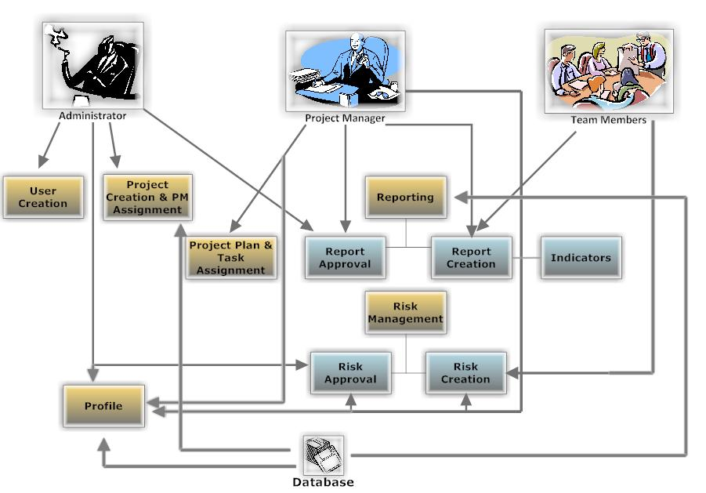**Figure-3:** How does project management assistant?

|  |  |  |
| --- | --- | --- |
| **Admin** | **Project Manager** | **Team Member** |
| * Project Creation * User Creation * Assign project manager | * Entering risks * Reject or approve new risk * Reporting risk * Update personal information * Task, role, time period assign. * Updating cost and report | * Report Creation & Forwarding * Enter new risk * Update cost information * Update personal information. * Change password |

**Table -2:** User Responsibilities

**Conclusion**

During this research, we learned a lot about the Project management assistant Systems. We tried to answer a lot of questions about what this system is, what it does, what are the benefits, what your web development technology and features are, and what applications are related to them. By the general structure of the system, we tried to give information about project and project cycle management concepts and phases, the phases of project development and planning within the scope of logical framework approach, and how to evaluate the project proposals using criteria. Finally, we tried to explain the basic concepts used in project management together.

**References**

[1] “Redmine Proje Yönetim Sistemi”, “Tanım”, Retrieved <https://ozguryazilim.com.tr/urunlerimiz/redmine-proje-yonetim-sistemi/> [05.05.2017].

[2] “sebaPLUS Nedir?”, “Neden sebaPLUS?”, Retrieved <http://www.sebaplus.com/tr/content/sebaplus-nedir/9> [05.05.2017].

[3] IEEE. IEEE Std 830-1998 IEEE Recommended Practice for Software Requirements Specifications. IEEE Computer Society, 1998

[4] “Mirosław J Skibniewski”, “Pollaphat Nitithamyong”, “Automation in Construction”, (27 February 2004), [07.05.2017]

# **SRS PREFACE**

Software Requirement System includes to everything about project. The documentation is planned to develop of the Project Management Assistant. In this part, we researched to what needs to be done and how to do that. Especially, more details should exist in this step of Senior Project. All team members shared to titles of Software Requirement System. The aim of all members creates an explicit system at the end of this part.

## **Introduction**

### **Purpose**

This documentation is written to clarify the Project Management System. The aim of this part includes to descriptions, functions, interfaces, and specific requirements. These mentioned titles are helpful for introducing the project.

Moreover, all explanatory information’s addresses to development team members and customers of Project Management Assistant when progresses of the project.

### **Scope**

Project Management Assistant is a useful system for scheduling and management information systems, manufacturing, budgeting. It will be a guide for keeping essential information’s about projects. There exists a project console to acquaint user with status of the project. This system provides user to enter stated information’s about the project. Every project has important parts like that deadlines, task sequences, cost calculations, resources.

Moreover, calculations or modifies budgets can be made easily. The user will be able to enter these subjects to the console. The mentioned system allows user to produce reports. It enhances communication between the project manager and the project team. To facilitate problem solving and project collaboration. This system will be made to use web technologies. And, users can easily follow the project which stated parts are made. Although the project is planned these contents, it does not provide leadership skills.

### **Definitions, Acronyms & Abbreviations**

**Definitions**

**Acronyms**

**API :** Application Programming Interface

**ASP.NET :** Web Application Framework

**DFD :** Data flow Diagram

**HW :** Hardware

**IEEE :** Institute of Electrical and Electronics Engineer

**PMA :** Project Management Assistant

**PBS :** Public Broadcasting Service

**PSPEC :** PISI Specification

**SDK :** Software Development Kit

**SPMP :** Software Project Management Plan

**SRS :** Software Requirements Specification

**SW :** Software

**UI :** User Interface

**Overview**

In SRS, PMA is planned to mention all details of the project. There are product perspective and functions, user characteristics, constraints, assumptions, and dependencies. Product perspectives constraint system interfaces, user, hardware, software, communication interfaces. System interfaces give information about program which relates with other programs. It shows that take or information to user. User interfaces is brought the interface for recently used the product. Hardware interface states the used hardware in the project. Software interface shows to be used software list in the project. Communication interfaces exist to need for protocol software. Project team gives the functions list. User characteristics say this project is developing for whom. Constraints include a different part from SPMP. Assumptions and Dependencies give information about training part and it constitutes different options.

Specific requirements show possible details with screenshots. External interfaces have all interfaces and a functional requirement includes every detail of the uses cases in PSPEC. Performance requirements mention how many user use the system at the same time. Class structures exist in the logical database requirements. Lastly, design constraints relate with architectural

## **Overall Description**

In this part, product perspective, functions, constraints, and assumptions will be explained briefly. It will provide to understand the requirement of product.

#### **Product Perspective**

### **System Interface**

In this part includes that project relates and integrations of the other programs. Moreover, it exists the examination about the project takes information or gives information. PMA is formed to project information’s of storage and updating via database system. Moreover, it requires using equipment which is a printer. The printer needs to give the output about reports. It provides to user given a feedback about general description of the project.

### **User Interfaces**

For the PMA user are categorized three types. Those types are:

* Admin,
* Project Manager,
* Team Member (staff).

We use different interfaces for those three types. Some users can not to have access some interface. Such as a team member cannot the process projects pages which include all project and their information. Whole users can access your own personal information and update own information. Also, manager access all user information but cannot update anyone’s information.

### **Admin**

Admin has more important functions. Admin define new projects, create new user, and assign project manager.

### **Project Manager**

Project manager can access projects, tasks, risks, costs, reporting, personal information, and time sheet. Manager is very competent for all functions. For example, only the managers affirm the new risks in risks page.

### **Team Member (Staff)**

Team member can access tasks, risks, personal information, and time sheet. A team member has very little authority.

### **Hardware Interfaces**

For PMA, we do not any hardware and other products.

### **Software Interfaces**

The system use Microsoft Operating system Windows 7-8-10 and use the Microsoft Visual Studio 2015 for web. MSSQL keep the all information about projects. When user send a query, database will send information.

### **Communication Interfaces**

There is internet connection needed for using this software. This software also works with TCP/IP protocols. So, your Windows operating system’s web services should be opened.

### **Memory Constraints**

On server side, the product can be run on a computer have minimum Pentium III-compatible processor or faster, 1GB Ram, 5 GB hard disk space and Ethernet card.

On user side, the product will be able to be run on a computer that have a Pentium III or better processor 512 MB Ram, Ethernet card and web browsers that are needed.

These are the minimum system requirements for the computers will be used. Any computer with better fragments may support better performance.

#### **Product Functions**

For Project Manager Assistant, we use some functions. Those functions are included user information, project information, task information, risk information and cost information. Also, we show the detail of those functions thanks to the use case diagram.

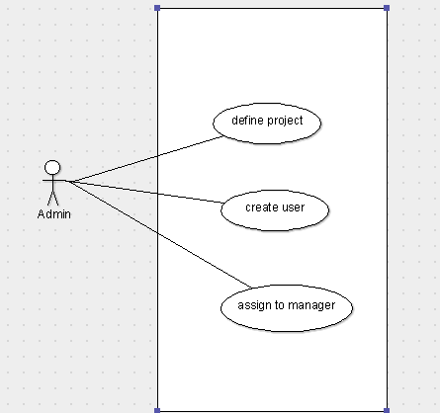

**Figure 1.** Use case for admin

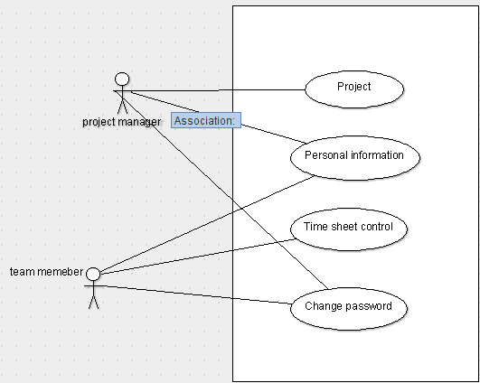

**Figure 2**. Use case for project manager and team member

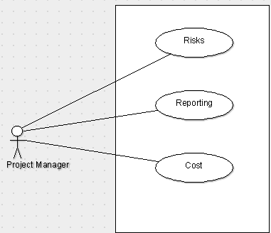

**Figure 3.** Use case for project manager

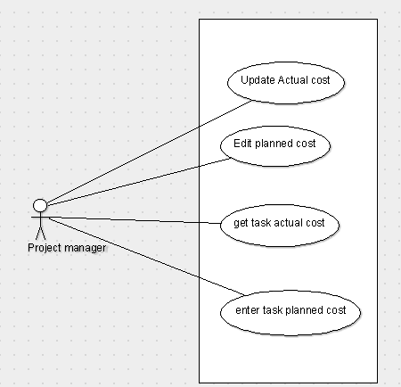

**Figure 4.** Project manager reaches cost information

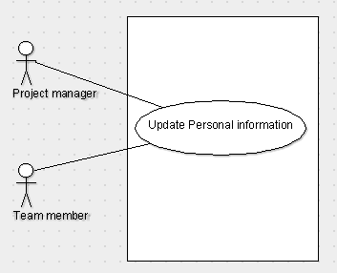

**Figure 5.** Updating personal information

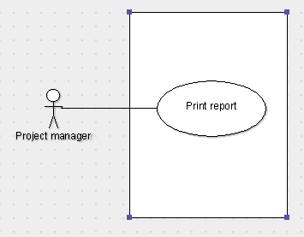

**Figure 6.** Maneger print the report about project.

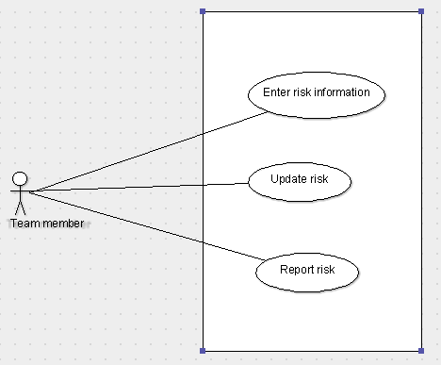

**Figure 7.** Team member use case

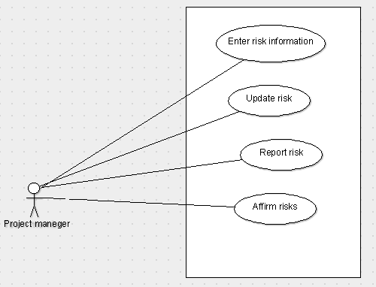

**Figure 8.** Manager use case for risks

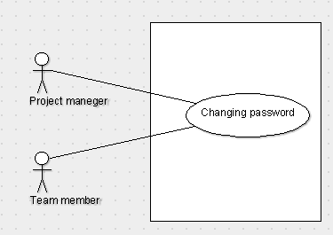

**Figure 9.** Changing password.

#### **User Characteristics**

No specific educational level is needed to use the product however the product is developed for companies to manage their projects, so all users should have familiarity with project plan discipline and management.

Users should also have moderate knowledge about network and Internet browsers usage.

#### **Constraints**

* Because of chosen software, product will be only able to be run on Microsoft Windows. (In other word, all the computers operating systems must be compatible with the specific software that are used in development of the product.
* Training time of team members on specific areas has a limited schedule.
* Temporary complexity and uncertainty of creating database for the product.
* Weakness in coding skills of team members.
* System requirements may change during the development.

### **Assumptions and Dependencies**

It is assumed that;

* Users will have recommended hardware,
* Users will use recommended versions of software,
* Users will use the product via Internet,
* No more than 10 users will connect the system at the same time.

## **Specific Requirements**

In this part of SRS document, we will briefly explain all product requirements, functional requirements and every I/O, data relationships of product.

**External Interfaces**

All external interfaces can be found in Appendices.

**User Interfaces**

User interfaces are explained in section 2.1.2 and some samples can be found in Appendices. Functions of interfaces are listed in section 2.1.2.

**Hardware Interface**

There are no hardware interfaces needed for using this software.

**Web Design Language**

Necessity of usage of the Internet requires TCP/IP Protocol usage between server and users. In addition, HTML codes and so HTTP will also be used for data exchanging between server and clients.

HTML codes will be written in ASP.NET format via C#.

**Operating System**

Our Project members use Windows 7, Windows 8 and windows 10, ASP.NET is not an independent platform; and, it still has to be configured on a server which uses Windows operating system.

**High Ordered Language**

Visual Web Developer Express platform is used to develop web applications. It is a part of the Microsoft Web Platform. Also, it provides free version for web developers. Visual Web Developers have ASP.NET web standards. Therefore, you will get work full featured web development environment.

**Functional Requirements**

|  |  |
| --- | --- |
|  | Login |
| Actor: | Project manager, team member |
| Priority: | High |
| Trigger: |  |
| Precondition: | User must connect to the internet |
| Basic Path: | 1. User enters user name and password. 2. The system verifies user name and password. 3. Home page is displayed. |
| Alternate Path: | * User fails;   System is warned the user for wrong user name or password.  Gives 3 chances for reentering the information. |
| Post Condition: | Users in home page. |
| Exception Path: | If the internet connection lost the system goes into standby. |

**Table 1**

|  |  |
| --- | --- |
| Use Case Name: | Project defining |
| Actor: | Admin |
| Priority: | High |
| Trigger: | Click Projects button |
| Precondition: | User must log in the system. |
| Basic Path: | 1. Admin define the new project 2. Admin assign a project manager for new project 3. Admin create new user |
| Alternate Path: | N/A |
| Post Condition: | Manager access the all information about the project and task |
| Exception Path: | 1. If the internet connection lost manager will log in the system again. 2. If admin cannot access the database, the system will send a message for re-trying. |

**Table 2**

|  |  |
| --- | --- |
| Use Case Name: | Personal Information |
| Actor: | Project Manager, Project team member. |
| Priority: | Medium |
| Trigger: | Click Personal Information |
| Precondition: | User must log in the system. |
| Basic Path: | User can refresh info which was changed |
| Alternate Path: | N/A |
| Post Condition: | Admin and manager access the personal information. |
| Exception Path: | 1. If wrong the information taken from the database, request will have sent again. 2. If the information is not actual, information in the database will be refreshed by person. |

**Table 3**

|  |  |
| --- | --- |
| Use Case Name: | Change Password |
| Actor: | Project manager. Team member |
| Priority: | Low |
| Trigger: | Click change password button |
| Precondition: | User must log in the system |
| Basic Path: | 1. User enter the password 2. User enter the new password 3. Confirm the new password 4. Password will be changed |
| Alternate Path: | System warned the user if new password and confirm password is not equal |
| Post Condition: | Admin or team member change the password |
| Exception Path: | If the internet connection lost the system goes into standby. |

**Table 4**

|  |  |
| --- | --- |
| Use Case Name: | Time Sheet |
| Actor: | Project manager and team member |
| Priority: | High |
| Trigger: | Click the time sheet button |
| Precondition: | User must log in the system |
| Basic Path: | 1. User fill the information 2. If team member pay an extra payment, he/she will fill the specific cost. |
| Alternate Path: | NA |
| Post Condition: | Information which was refresh or fill, will be saved |
| Exception Path: | 1. If the database is not save the new information and sent an error message, user will be try again. |

**Table 5**

|  |  |
| --- | --- |
| Use Case Name: | Cost |
| Actor: | Project manager |
| Priority: | High |
| Trigger: | Click the cost button |
| Precondition: | User must login the system then click the project button. |
| Basic Path: | User will be fill the cost. |
| Alternate Path: | NA |
| Post Condition: | System shows actual cost, planned cost, task actual cost, task planned cost |
| Exception Path: | If the connection lost the system goes into standby. |

**Table 6**

|  |  |
| --- | --- |
| Use Case Name: | Reporting |
| Actor: | Project manager |
| Priority: | Medium |
| Trigger: | Click reporting button. |
| Precondition: | User must log in the system. |
| Basic Path: | **1**. After login the system manager will choose a project.  **2.** After choosing the project, click to reporting button. |
| Alternate Path: | N/A |
| Post Condition: | The report is printed. |
| Exception Path: | If the data is not actual, the database will be refreshed. |

**Table 7**

|  |  |
| --- | --- |
| Use Case Name: | Tasks information |
| Actor: | Project manager and team member |
| Priority: | High |
| Trigger: | Click the tasks button |
| Precondition: | User must log in the system |
| Basic Path: | 1. User refreshes the information about how much task is completed. |
| Alternate Path: | NA |
| Post Condition: | Task information is refreshed. |
| Exception Path: | 1. If the internet connection lost the system goes into standby. 2. User login the system again |

**Table 8**

|  |  |
| --- | --- |
| Use Case Name: | Risk information |
| Actor: | Team member and project manager |
| Priority: | High |
| Trigger: | Click the risk button |
| Precondition: | User must log in the system |
| Basic Path: | 1. If a new risk accrue team member will fill their new risk column 2. If one of the potential risks accrue member will be denoted. 3. If the project manager appropriates the new risks, manager will fill the acceptance part. |
| Alternate Path: | NA |
| Post Condition: | Risks follow up. And new risks upload the system. |
| Exception Path: | 1. If the internet connection lost user will log in the system again. |

**Table 9**

## **Performance Requirements**

No more than 10 users will connect the system at the same time. But also, it depends on server. There are many transactions are included by PMA. These transactions shall be processed less than one second but also this depends on internet speed and connectivity. Our software will not process big packets. So, performance requirements are not extraordinary. The simple PC which can using internet is enough for the system.

## **Logical Database Requirements**

We show relationships between classes, their attributes, and candidates with Class diagram. When we start to create our database, we will use class diagram.

## **Software System Attributes**

#### Reliability

In our system, the concept of reliability is one which can prove to be of paramount importance to the project management team and or the project management team leader, as errors in reliability can cause productivity to decline significantly. Specifically speaking, reliability refers to the probability and or the likelihood that a given product will perform in the way and or manner it was intended to perform in the efforts that have been deemed required of that given product within or under a specific period required.

Products that have high levels of reliability are preferred for a wide and varied number of reasons. One of the most significant reasons for this is that, when product reliability is higher and or greater it allows for less wasted energy and less redundancy, and allows more members of the project team to focus on additional aspects of the project sooner. Products with lower reliability will cause more wasted energy, and more redundancy.

#### Availability

The goal of the PMA Working group is to move the PMA speciﬁcation all the way to establishment. This requires extensive testing between different PMA implementations to iron out uncertain portions of the draft standard.

#### Security

Security of the system will be provided using some high developed security functions and programs that are provided by security companies. The server has several firewalls and anti-hack systems to prevent the attacks to database. In the database, there will be a unique table that can be reached only the user.

**Denial-of-Service Attack**

A denial-of-service (DOS) attack is something done to preclude someone from accomplishing useful work. Typically, a DOS attack takes one of two forms: nuisance packets or the preclusion of packets from flowing between two nodes. There is little that can be done to prevent this nuisance packet attack, and the sender can always spoof the source address. However, service providers can filter IP packets in their routers to assure the IP source address of a packet is genuine before it is forwarded.

**Replay Attacks**

It is feasible for an attacker to obtain a copy of a legitimate Registration Request, store it, and then replay it later to accomplish a forged care-of address for a mobile node. To avoid this replay attack from occurring, the mobile node produces a unique value for the identification field in each of the successive endeavors for registration. The identification field is made in such a way as to allow the home agent to ascertain what the subsequent value should be. The attacker is hampered because the identification field in his stored Registration Request will be known as being outdated by the home agent.

**Session-Stealing Attack**

An attacker performs a session stealing attack by waiting for a valid node to authenticate itself and initiate an application session, then captures the session by masquerading as the legitimate node. Typically, this requires the attacker to transmit numerous nuisance packets to thwart the legitimate node from recognizing that the session has been captured.

#### Portability

The PMA portal can be reached from any computer that has internet connection and web browser.

#### Maintainability

Maintenance will be provided for the system by team. If any update or change in the portal, the changes will be done by the team. Team members control the database updates done by server automatically.

## **Gamification**

In addition to the similar programs we have compared above, there is a rewarding and punishment system in the project that we want to do. This system called gamification.

For business purposes: We can say that this is the most basic differentiator for the game. Enhancing the behavior of a system should be the realization of the primary business goals. Behaviors that are not directly directed at business goals can of course be found in the system. Such behavior serves, at least indirectly, to business goals, or at least meets the 'fun' requirement of the application. But it is very important for a successful application that the behaviors to be reinforced are directed towards the business golas.

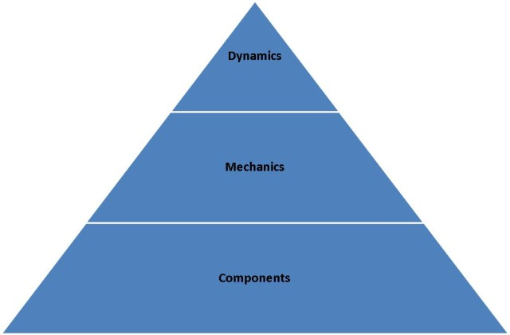

Dynamics: It consists of elements that determine the concept at the top level. If acting is thought of as a language, these elements correspond to the grammar of the language. Dynamics can be thought of as the hidden structure of the system. They provide integrity and consistency. Constraints in design are made up of elements that are not very easy to describe, such as emotion, progression, storytelling. The pyramid is in the metaphor. They are scarce in quantity but they are of the highest quality.

Mechanics: Elements that provide and regulate movement. If they look in terms of language metaphor they come together. Elements such as luck, competition, cooperation, shopping, challenges ... are elements of this group.

Components: Dynamic and mechanics describe the way a system works, while components represent the output of this work. If we look at the language metaphor again, their counterparts will be 'names'. Badges, avatars, levels, scores, leadership tables, teams, bosses, etc. There are many things like.

As a result, gamification we want to use in the project management assistant program, unlike other programs. We believe that employees will be more effective in reducing stress and achieving their goals.

## **Appendices**

|  |  |
| --- | --- |
| Welcome To Home Page | |
| Admin & Manager Log In   |  |  | | --- | --- | | Account Name | Password | |  |  |  |  | | --- | | Log In Button | | Staff Log In   |  |  | | --- | --- | | Account Name | Password | |  |  |  |  | | --- | | Log In Button | |

|  |  |  |
| --- | --- | --- |
| Home  Button | Home Page of  Admin & Manager | Logout  Button |
| Projects  Button |
| Time Sheet  Button |
| Personal Information  Button |
| Change Password  Button |

|  |  |  |
| --- | --- | --- |
| Home  Button | Home Page of  Staff | Logout  Button |
| Tasks  Button |
| Time Sheet  Button |
| Personal Information  Button |
| Change Password  Button |

|  |  |  |  |  |  |  |  |
| --- | --- | --- | --- | --- | --- | --- | --- |
| Home  Button | Projects Page of  Admin & Manager   |  | | --- | | Project Name  Text Box | | Project Manager  Text Box | | Start Day  Text Box | | Finish Day  Text Box | | Completeness  Percentage  Text box | | Logout |
| Risks  Button |
| Report  Button |
| Cost  Button |
| Tasks  Button |

|  |  |  |  |  |  |  |  |  |  |
| --- | --- | --- | --- | --- | --- | --- | --- | --- | --- |
| Home  Button | Time Sheet Page of  Admin & Manager   |  | | --- | | Name Surname of Staff  Text Box | | Status  Text Box | | Task Name  Text Box | | Start Day  Text Box | | Finish Day  Text box | | # Hours Per Day  Text Box | | Specific Cost  Text Box | | Logout |
| Projects  Button |
|  |

|  |  |  |  |  |  |  |  |  |  |
| --- | --- | --- | --- | --- | --- | --- | --- | --- | --- |
| Home  Button | Personal Information Page of  Admin & Manager   |  | | --- | | Name  Text Box | | Surname  Text Box | | Phone Number  Text Box | | E-mail  Text Box | | Address  Text box | | Graduate  Text Box | | Under Graduate  Text Box | | Logout |
| Update  Button |
|  |

|  |  |  |  |  |  |
| --- | --- | --- | --- | --- | --- |
| Home  Button | Change Password Page of  Admin & Manager   |  | | --- | | Current Password  Text Box | | New Password  Text Box | | New Password Confirm  Text Box | | Logout |
| Save Changes  Button |
|  |

|  |  |  |  |  |  |  |  |  |  |
| --- | --- | --- | --- | --- | --- | --- | --- | --- | --- |
| Home  Button | Tasks Page   |  | | --- | | Staff Name | | Task Name | | Start Day | | Finish Day | | Task Definition | | Project ID | | Completeness Percentage | | Logout |
| Risks  Button |
|  |

|  |  |  |
| --- | --- | --- |
| Home  Button | Cost Page of Admin & Manager | Logout |
|  |

|  |  |  |  |  |  |  |  |  |  |  |
| --- | --- | --- | --- | --- | --- | --- | --- | --- | --- | --- |
| Home  Button | Report Page   |  | | --- | | Project name  Text Box | | Task Name Text Box | | Start Date Text Box | | Finish Date Text Box | | Actual Cost Text Box | | Planned cost Text Box | | Completeness Percentage Text Box | | Resultant Risks Text Box | | Logout |
|  |

# **SDD PREFACE**

Software Design Document is a technical definition about the system. This documentation mentions that architecture and design of the project. Before preparing the SDD, Software Requirement System was examined by team members. SRS includes more information about the Project and SDD is an organization, behavior and collaborations between modules. Project Management Asistant has many requirements and they are mentioned in SRS. SDD includes technology of the requirements and its architecture. The documentation provides an understandable guide for developer. It was prepared acoocrding to IEEE 1016.

## INTRODUCTION

**Purpose**

Software Design Document describes the design and architecture of Project Management System. The aim of documentation examines decompositon of the system, Technologies and responsibilites into modules. SDD is an implementation for before coding. A person, who does not know anything about the project, can learn everything about Project Management System.

**Scope**

The system architecture and software design are details of the description in this documentation. Project Management System is like preparing to the implementation. When we look at the Softare Requirement System, we seperated simple parts according to individual who enters the system. This part contributes to the Project that some of them has only its own pages. It can be made some changes, updates, deleting with helping a database. Database is useful for holding the all information about the Project Management System. So that, this documentation brings user information which has more reality and more visual. And also, it is a contribution for software.

**Definitions, Acronyms and Abbreviations**

**Definitions**

**Employee List:** It is the document given by the senior management to the admin, including the company’s employee list.

**Report:** It is document formed by all of the users in order to inform senior personel about the costs, working hours and works that are done.

**Acronyms**

**API:** Application Programming Interface

**DB:** Database

**GUI:** Graphical User Interface

**PM:** Project Manager

**RTM:**Requirement Traceability Matrix

**SRS:** Software Requirement System

**SDD:** Software Design System

**IEEE:**Institute of Electrical and Electronics Engineers

**REFERENCES**

**1**.IEEE SDD 1016 - IEEE Recommended Practice for Software Design Descriptions

**2.**Somerville, I., 2004. “Software Engineering”, USA: ADDISON-WESLEY, seventh edition.

**3.**Pressman, Roger S., Software Engineering, 4th edition, McGraw-Hill, 1997

For Project Management SDD Version1.0

**4.**Fairley, R. E.,Workbreakdown Structure, Software Engineering Project Management, IEEE CS Press, 1997

## SYSTEM OVERVIEW



**Figure 1**: System Overwiew

|  |  |  |
| --- | --- | --- |
| **Admin** | **Project Manager** | **Team Member** |
| * Project Creation * User Creation * Assign project manager * Rewarding | * Entering risks * Reject or approve new risk * Reporting risk * Update personal information * Task, role, time period assign. * Updating cost and report * Changing password. | * Report Creation & Forwarding * Enter new risk * Update cost information * Update personal information. * Change password |

**Table 1:** User Responsibilities

## SYSTEM COMPONENTS

**Decomposition Description**

**Module Decomposition**

Our project, the Project Management Assistant has following modules.

* Project Organization Module
* Login Module
* Risk & Cost Management Module
* Task Management Module
* Profile Module

**Project Organization Module**

**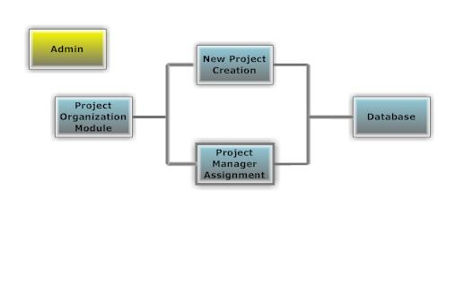**

**Figure 2:** Project Organization

##### **Identification**: Project Organization Module

**Purpose:** Establishing new projects and administrative operations is mainly functions of this module. In addition, Project managers and team members assignments also will be done in this module.

**Functions:**

* New project is established by admin.
* Project manager is assigned to the projects by admin.

**Sub-modules:**

* New Project Creation
* Project Manager Assignment

**Table 2:** Project Organization

**New Project Creation Sub-Module**

###### ***Identification:*** *New Project Creation Sub-Module*

**Purpose:** Allowance of admin to create new projects.

**Functions:**

* New projects name is entered by admin.
* New project is added by admin.

**Sub-ordinates:** Connection to DB.

**Table 3:** New Project

**Project Manager AssignmentSub-Module**

###### ***Identification:*** *Project Manager Assignment Sub Module*

**Purpose:** Allowance of admin to assign Project managers to the projects:

**Functions:**

* Project is selected from list by admin.
* Project manager is selected from list by admin.
* Project manager is assigned to the project by admin.

**Sub-ordinates:** Connection to DB.

**Table 4:** Project Manager Assignment

**Login Module**

**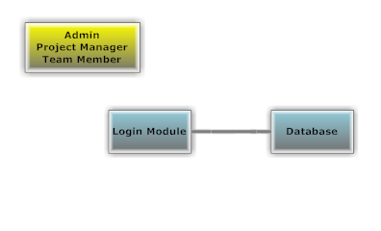**

**Figure 3:** Login

**Identification:** Login Module

**Purpose:** Allowance of admin, Project managers and team members to log in the system.

**Functions:**

* Admin project managers and team members will be able to log in system.
* Users types username.
* User types password.
* Users checked in database whether they are authorized to log in or not.

**Sub-ordinates:** Connection to DB.

**Table 5:** Login

**Risk & Cost Management Module**

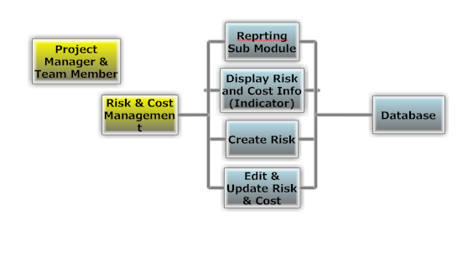

**Figure 4:** Risk & Cost Management

**Identification:** Risk & Cost Mangement Module

**Purpose:** Give permission to Project managers to creating new risks, editing & changing existing risks and displaying the same risks. In addition it also gives permission to team members to create new risks for their project managers approval.

**Functions:**

* Project Managers will be able to select a project from list to edit costs & risks of the project
* Monitoring existing risks and current both actual cost and planned cost will be provided.
* Project Managers will be able to approve or reject received risks from team members.
* Team members will be able to create and forward new risks.

**Sub-modules:**

* Display & Edit Risks & Costs
* Create New Risk Risk
* Approve Forwarded Risk (Only PM)

**Table 6: Risk & Cost Managemen**

**Display Risks & CostsSub-Module**

**Identification:** Display Risks Sub-Module

**Purpose:** Make Project managers and team members able to monitor actual risks and costs that have been recieved or sent.

**Functions:**

* Project manager will be able to see all risks and cost information for a specified project that is selected from a list. In addition they also will be able to see updated or newly created risks or changed cost of a project.
* Project Managers will be able to edit or terminate risks and update costs
* Team members will be able to see risk and cost updates that have been done by them

**Sub-ordinates:** Connection to DB.

**Table 7: Display of Risk**

**Create Risk Sub-Module**

**Identification:**Create Risk Sub-Module

**Purpose:** Make project managers and team members able to create new risks and forwarding and approving them.

**Functions:**

* Project managers will be able to create new risks, with their brief description for a specified project.
* Team members will be able to create new risks and forwarding them to project managers for approval.

**Sub-ordinates:** Connection to DB.

**Table 8: Risk Creation**

**Edit & Update Risk Cost Sub-Module**

**Identification:**Edit Risk Sub-Module

**Purpose:** Make Project managers and team members able to edit existing risks and update actual cost.

**Functions:**

* Project managers will be able to edit risks and update costs of a project that is selected from a list.
* Team members will be able to edit cost and risk information which will be invalid till project managers approval

**Sub-ordinates:** Connection to DB.

**Table 9: Risk & Cost Edition**

**Reporting Sub-Module**

**Identification:**Create New Report Sub-Module

**Purpose:** Allow team members to create reports for briefly describing updates and changes about cost and risk done by them to Project managers.

**Functions:**

* Team members will be able to create new reports and forwarding them.
* Project Managers will be able to display forwarded reports

**Sub-ordinates:** Connection to DB.

**Table 10: New Report Creation**

**Profile Module**

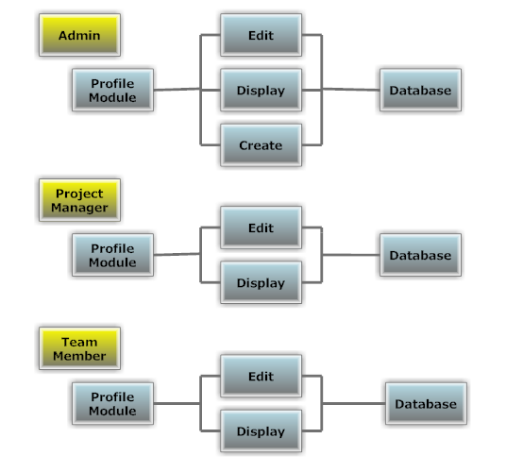

**Figure 5:** User Profiles

**Identification:** Profile Module

**Purpose:** Allow admin to create new accounts for Project managers and team members. In addition allow users to edit their personal profile pages.

**Functions:**

* Admin will be able to create new account.
* All users will be able to edit profile settings.

**Sub-Modules:**

* Edit Profile
* Display Profile
* Create Profile

**Table 11: Profile**

**Edit Profile Sub-Module**

**Identification:**Edit Profile Sub-Module

**Purpose:** Allow non-admin users to edit their personal profile page.

**Functions:**

* Edit address
* Edit phone number
* Edit e-mail

**Sub-ordinates:** Connection to DB.

**Table 12: Profile Edition**

**Display Profile Sub-Module**

**Identification:** Display Profile Sub-Module

**Purpose:** To allow users monitor other user sprofile page.

**Functions:**

* TC , name, surname, email, address, number, of user will be displayed.
* TC, name, surname, email, address, number, of a project manager or a team member selected from a list will be displayed.

**Sub-ordinates:** Connection to DB.

**Table 13: Display Profile**

**Create Profile Sub-Module**

**Identification: Create Profile Sub-Module**

**Purpose:** To allow admin create new user profile.

**Functions:**

* TC, name, surname of a user will be entered by admin

**Sub-ordinates:** Connection to DB.

**Table 14: Profile Creation**

**Task Management Module**

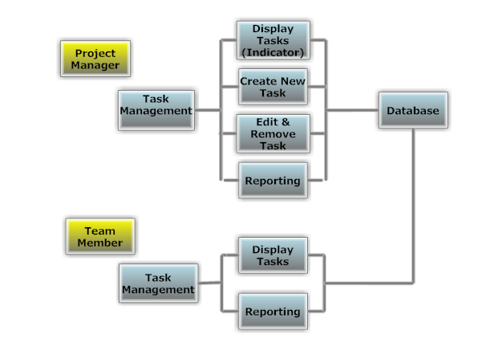

**Figure 6:** Task Management

**Identification:** Task Management Module

**Purpose:** To allow Project managers assign tasks to team members. In addition allow to team members to display received tasks.

**Functions:**

* Project manager assign tasks to team members
* Team members can display received tasks

**Sub-Modules:**

* Display Tasks
* Create New Task (only available for Project Managers)
* Edit & Remove Task

**Table 15:Task Management**

**DisplayTasksSub-Module**

**Identification:** Display Tasks Sub-Module

**Purpose:** To allow team members and Project managers monitor tasks.

**Functions:**

* Project manager and Team member will be able to see all taks in a list. In addition team members will be able to see recently added new tasks.
* Information about selected task is displayed.

**Sub-ordinates:** Connection to DB.

**Table 16: Display Task**

**Create New TaskSub-Module**

**Identification:**Create New Task Sub-Module

**Purpose:** To allow Project managers assign tasks to team members.

**Functions:**

* Project manager creates a task
* Project manager defines start and finish date for the task
* Project manager enters cost
* Project manager select a team member from a list
* Project manager assign task to team member

**Sub-ordinates:** Connection to DB.

**Table 17: Task Assignment**

**Edit & Remove Task Sub-Module**

**Identification:**Edit & Remove Task Sub-Module

**Purpose:** To allow Project managers edition and removal of tasks.

**Functions:**

* Project manager select a task from list
* Project manager sign selected task as cancelled or finished.
* Task is terminated.

**Sub-ordinates:** Connection to DB.

**Table 18: Edit & Remove Task**

**Reporting Sub-Module**

**Identification:** Reporting Sub-Module

**Purpose:** To allow team members create and send reports to their Project managers about a selected task.

**Functions:**

* Team Member selects a task form list
* Team member types definition and descriptions to
* Project managers will be able to see forwarded reports

**Sub-ordinates:** Connection to DB.

**Table 19:** Reporting

**Rewarding Module**

**Identification:** Rewarding Module

**Purpose:** Only the administrator can reward the team member with extra fee or permission.

**Functions:**

* The administrator selects a member form list
* Select member’s reward
* Project managers will be able to see rewarding team members

**Sub-ordinates:** Connection to DB.

**Table 20: Rewarding**

**Data Decomposition**

This section is about describing each data entity and its logical structure. All data are saved in the database. We will take information from the database thanks to the query. We described a data dictionary.

|  |  |  |
| --- | --- | --- |
| **Column name** | **Type** | **Column statu** |
| Project\_name | Varchar(60) | Not null |
| Project\_id | Number(6) | Not null (primary key) |
| Project\_manager | Varchar2(60) | Not null |
| Start\_day | Date | Not null |
| Finish\_day | Date | Not null |
| %completed | Number(2) | Not nul |
| Planned\_cost | Float | Not null |
| Actual\_cost | Float | Not null |
| New\_actual\_cost | flaot | Not null |
| T\_date | date | Not null |

**Table 21:**project\_information

|  |  |  |
| --- | --- | --- |
| **Column name** | **Type** | **Column statu** |
| Project\_id | Number(6) | Not null(foreign key) |
| Task\_name | Varchar2(60) | Not null |
| Task\_id | Number(12) | Not null(primary key9 |
| Person | Varchar2(80) | Not null |
| Start\_day | Date | Not null |
| Finish\_day | Date | Not null |
| %completed | Number(2) | Not nul |
| Specific\_cost | Float(13) | Not null |
| Role | Varchar2(30) |  |

**Table 22:**task\_information

|  |  |  |
| --- | --- | --- |
| **Column name** | **Type** | **Column statu** |
| Project\_id | Number(6) | Not null(foreign key) |
| Risk | Varchar2(255) | Not Null |
| Probability | Number(3) | Not Null |
| Impact | Varchar2(255) | Not Null |
| Mitigation | Varchar2(255) | Not Null |
| New\_risk | Varchar2(255) | Null |
| Acceptance\_of\_new\_risk | Varchar2(70) | Null |

**Table 23:**risk\_information

|  |  |  |
| --- | --- | --- |
| **Column name** | **Type** | **Column statu** |
| Project\_id | Number(6) | Not null(foreign key) |
| Task\_id | Number(12) | Not null(foreign key) |
| Actual\_cost | Float(13) | Not null |
| Planned\_cost | Float(13) | Not nul |

**Table 24:**cost\_information

|  |  |  |
| --- | --- | --- |
| **Column name** | **Type** | **Column statu** |
| Tc | Number(11) | Not null |
| Name | Varchar2(60) | Not null |
| b-date | date | null |
| Phone\_no | Number(12) | Null |
| e-mail | Varchar2(30) | Null |
| undergraduate | Varchar2(100) | Null |
| Graduate | Varchar2(100) | Null |
| Experiences | Varchar2(100) | Null |

**Table 25:**personal\_information

|  |  |  |
| --- | --- | --- |
| **Column name** | **Type** | **Column statu** |
| Tc | Number(11) | Not null(foreign key) |
| Role | Varchar2(20) | Not null |
| Task\_id | Number(15) | Not null |
| Hourly\_cost | Float(13) | Not null |

**Table 26:**follow\_up\_hours

|  |  |  |
| --- | --- | --- |
| **Column name** | **Type** | **Column statu** |
| Role\_name | Varchar2(50) | Not null |
| role\_id | Number(5) | Not null (primary key) |

**Table 27:**ROLE\_information

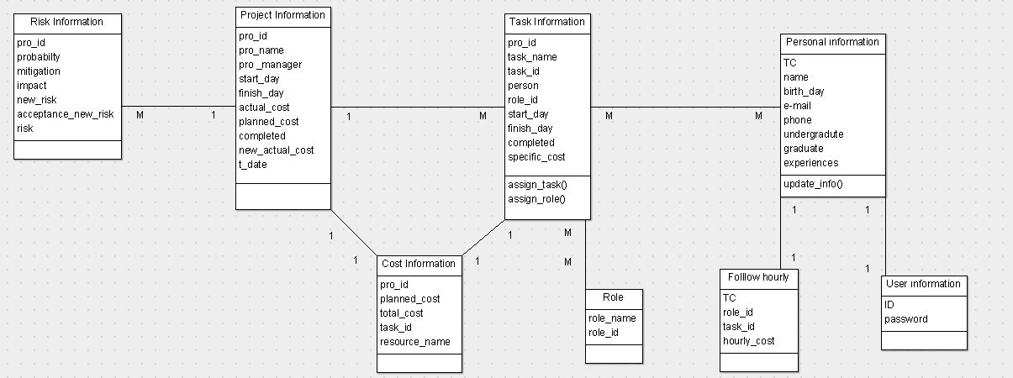

**Figure 7:** Database Design

**Dependency Description**

**Intermodule Description**

|  |  |  |  |  |  |  |
| --- | --- | --- | --- | --- | --- | --- |
| **PMA Modules** | Login Module | Project Organization Module |  | Task Management Module | Profile Module | Risk & Cost Management Module |
| Login Module | **X1** |  |  |  |  |  |
| Project Organization Module | **X2** |  |  |  | **X3** |  |
| Task Management Module | **X4** | **X5** |  |  |  |  |
| Profile Module | **X6** |  |  |  | **X7** |  |
| Risk & Cost Management Module | **X8** | **X9** |  | **X10** |  |  |

**Table 28:** Intermodule description

X1,X2,X4,X6,X8 means that user must be authorized to login to use all modules of the system.

X5,x9 means that task, risk and cost management cannot be done unless the project is created

X10 means risk & cost management cannot be done unless task management is planned

X3,x7 means that some functions in project organization module and profile module cannot be done unless user has some special authorization. Such as admin’s user creation or project organization.

**Data Dependencies**

There are relations between data entities. These relationships are provided in detail below.

|  |  |  |
| --- | --- | --- |
| **Name** | **Type** | **Size** |
| Project\_id | number | 6 |
| Task\_id | number | 12 |
| Planned\_cost | float | 13 |
| Actual\_cost | float | 13 |

**Table 29**:cost\_information

**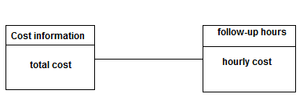**

**Attributes :**project\_id,task\_id,planned\_cost,actual\_cost

**RelationshipType:**One - to – one

**Figure 8:**cost-follow up

**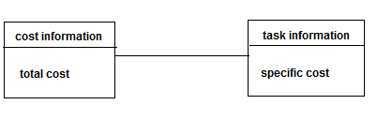**

**Attributes :**project\_id,task\_id,planned\_cost,actual\_cost

**RelationshipType:**One - to – many

**Figure 9:**cost-task

|  |  |  |
| --- | --- | --- |
| **Name** | **Type** | **Size** |
| Project\_name | Varchar2 | 60 |
| Project\_id | Number | 6 |
| Project\_manager | Varchar2 | 60 |
| Start\_day | Date | 8 |
| Finish\_day | Date | 8 |
| Planed\_cost | Float | 13 |
| Actual\_cost | Float | 13 |
| %completed | Number | 3 |
| New\_actual\_cost | float | 13 |
| T\_date | date | 8 |

**Table 30:**project\_information

**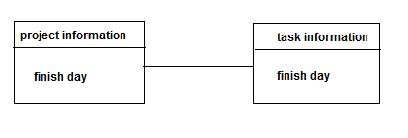**

**Attributes :**project\_id,project\_name,project\_manager, start\_day, planned\_cost,actual\_cost, %completed

**RelationshipType:**One - to – one

**Figure 10:**Project-task

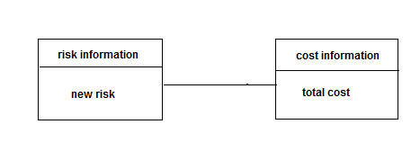

**Attributes :**project\_id,task\_id,planned\_cost,actual\_cost

**RelationshipType:**Many - to – one

**Figure 11:**risk-cost

**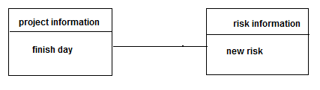**

**Attributes :**project\_id,project\_name,project\_manager, start\_day, planned\_cost,actual\_cost, %completed

**RelationshipType:**One - to –many

**Figure 12:**Project - risk

|  |  |  |
| --- | --- | --- |
| **Name** | **Type** | **size** |
| Project\_id | number | 6 |
| Task\_name | Varchar2 | 60 |
| Task\_id | number | 12 |
| Person | Varchar2 | 60 |
| Start\_day | date | 8 |
| Finish\_day | date | 8 |
| %completed | number | 3 |
| Specific\_cost | float | 13 |
| Role | Varchar2 | 30 |

**Table 31**:task\_information

**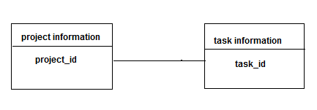**

**Attributes :**project\_id,task\_name,task\_definition, start\_day,finish\_day , %completed, specific\_cost

**RelationshipType:**One - to – one

**Figure 13:**Project-task

|  |  |  |
| --- | --- | --- |
| **Name** | **Type** | **Size** |
| Tc | number | 1 |
| Role | Varchar2 | 20 |
| Hourly\_cost | float | 13 |
| Task\_id | number | 15 |

**Table 32:** follow\_up\_hours

**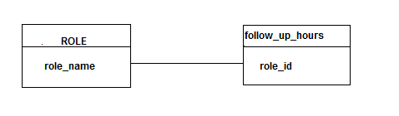**

**Attributes :**task\_id, hourly\_cost,name,surname.

**RelationshipType**: Many - to – one

**Figure 14:**statu-follow up

**INTERFACE DESCRIPTION**

**Module Interfaces**

**User Interface**



**Figure 15:** LoginPage

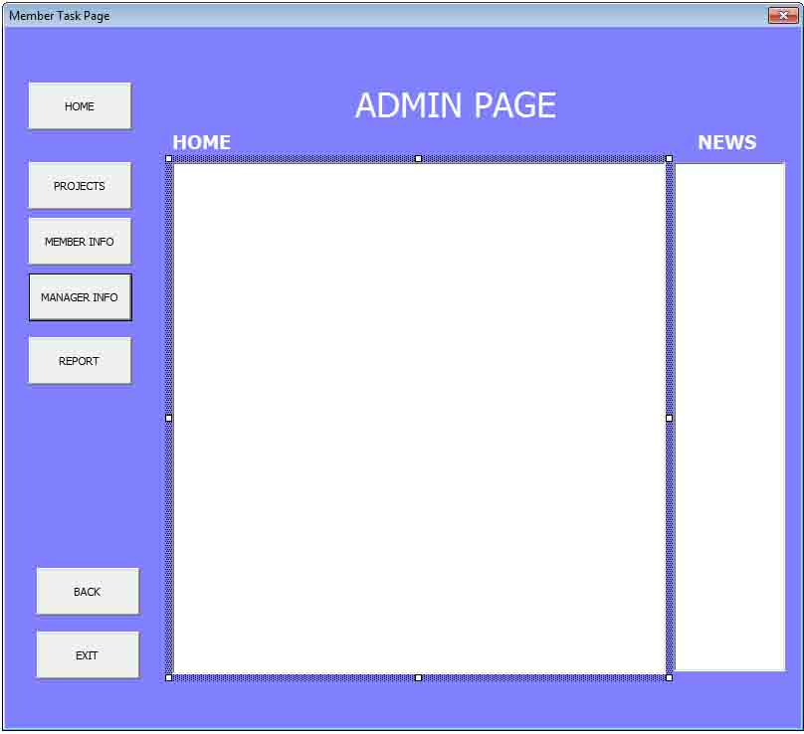

**Figure 16:** Admin Home Page

**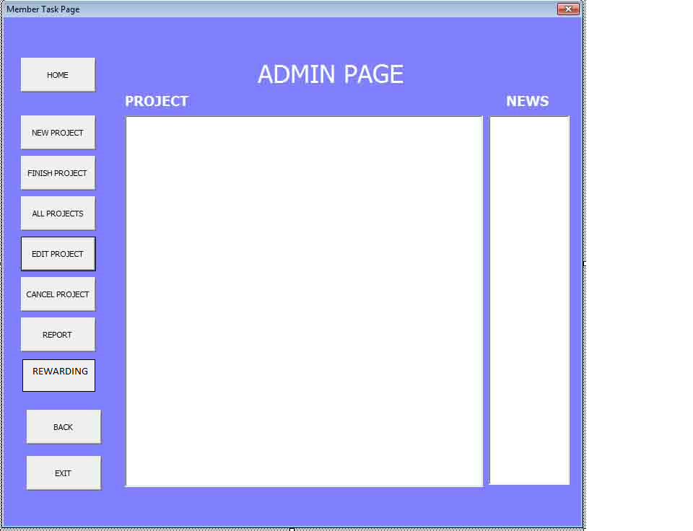**

**Figure 17 :** Admin Project Page

**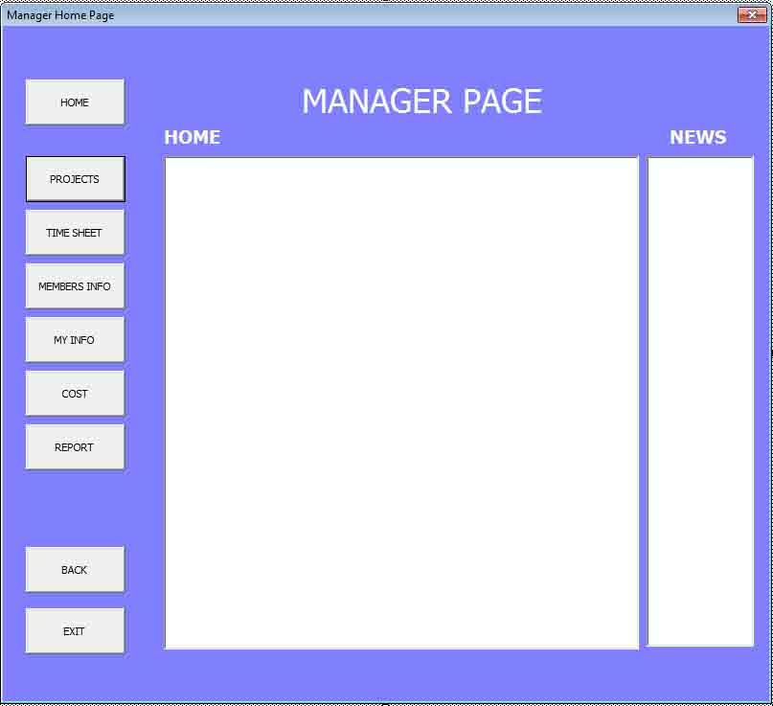**

**Figure 18:** Project Manager Home Page

**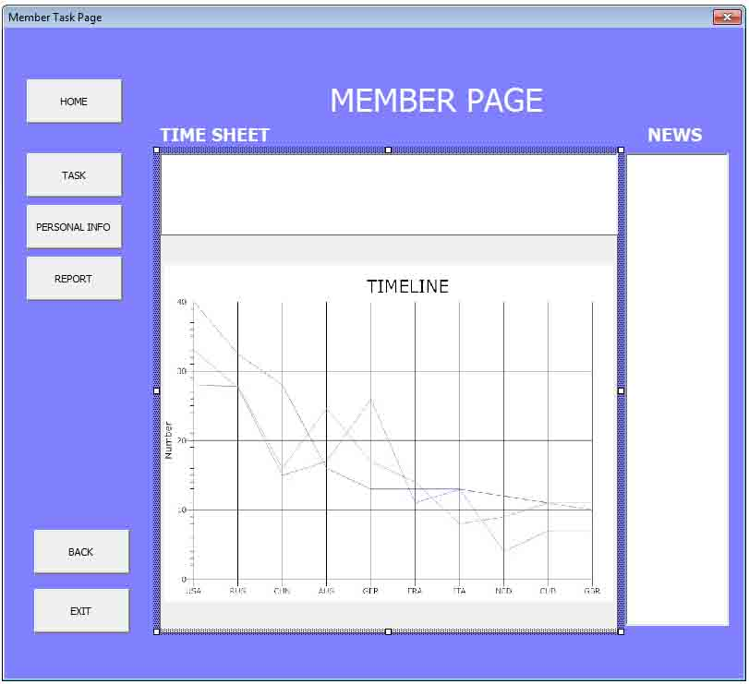**

**Figure 19 :** Member Time Sheet

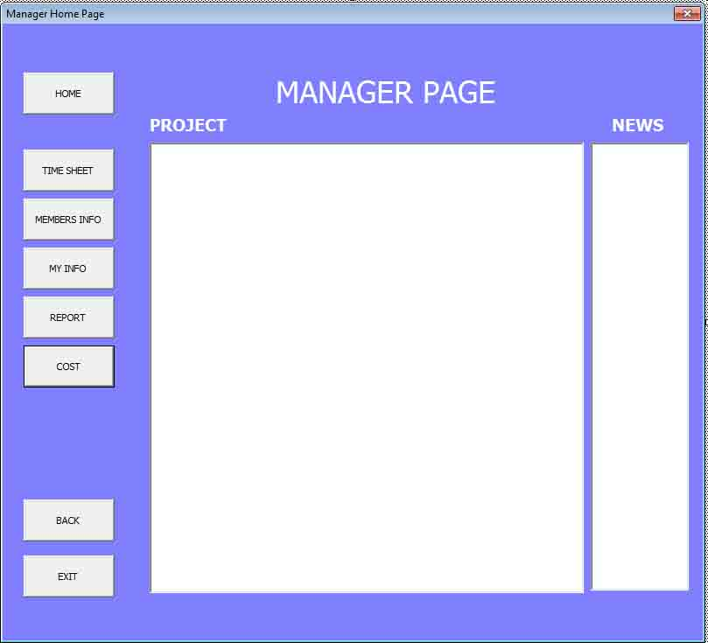

**Figure 20:** Project Manager Project Page

**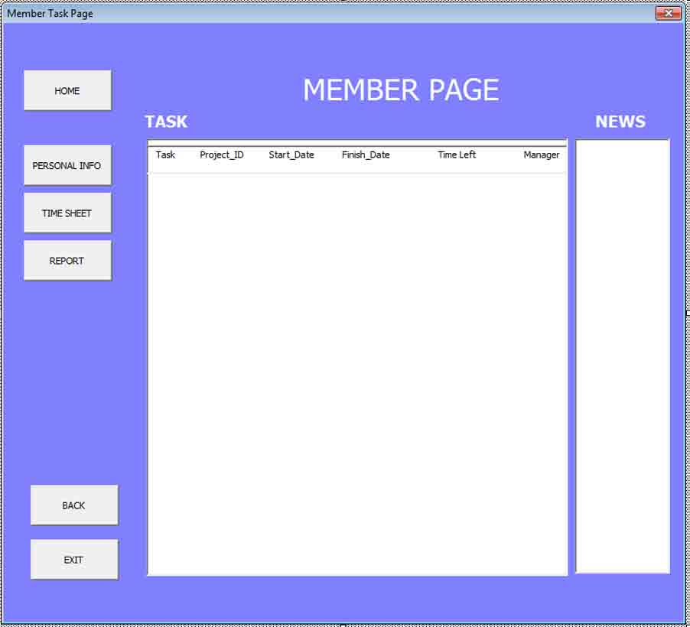**

**Figure 21 :** Member Task Page

## DETAILED DESIGN

**Module Detailed Design**

**Class Diagram**

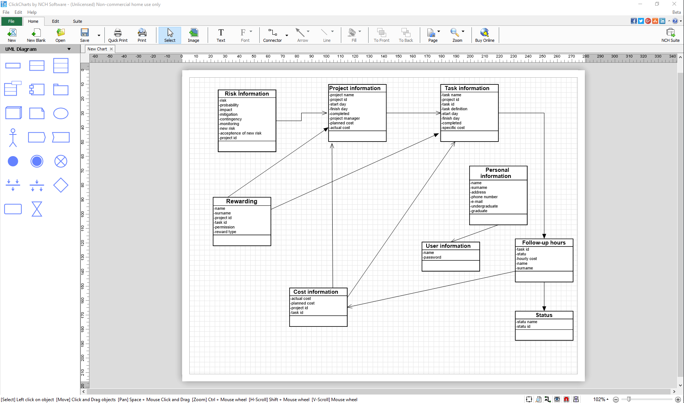

**Figure 23:** Class Diagram

**Project Organization Activity Diagram**

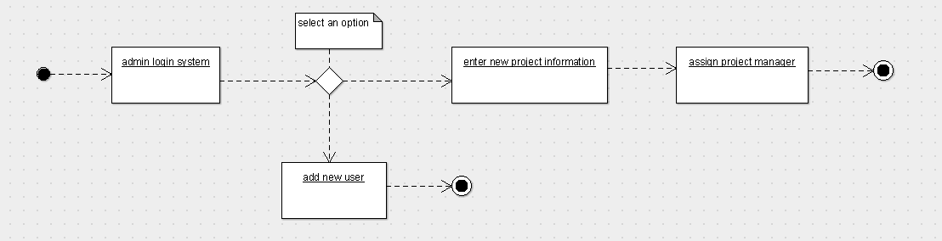

**Figure 22 :** Admin Login Module Activity Diagram

**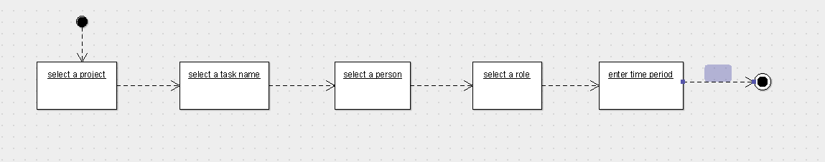**

**Figure 23:**Task Assign Module Activity Diagram

**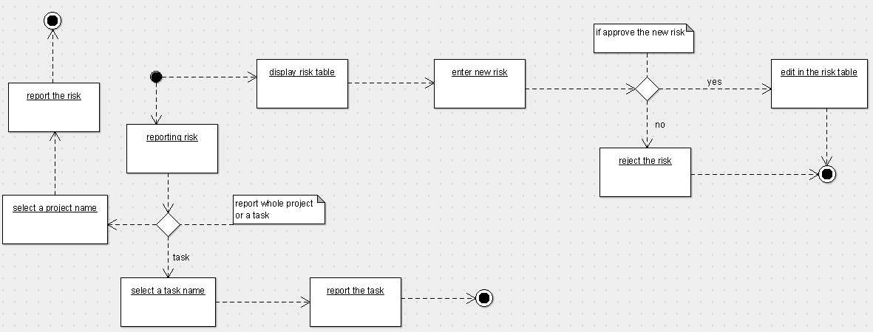**

**Figure 24:**Risk Module Activity Diagram

**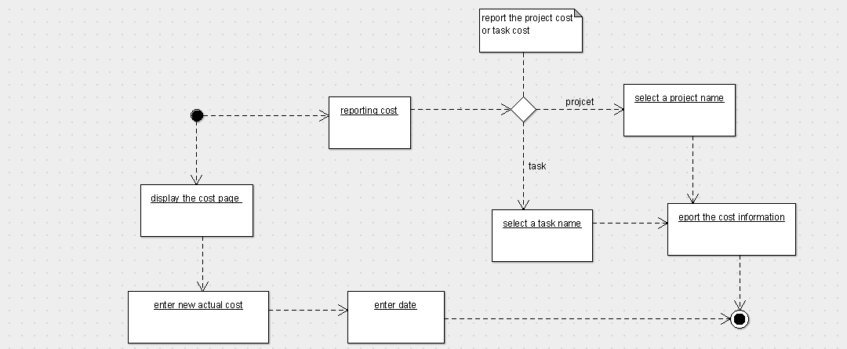**

**Figure 25:**Cost Module Activity Diagram

**Data Detailed Design**

In this section, we show the type of the data and size of the data.

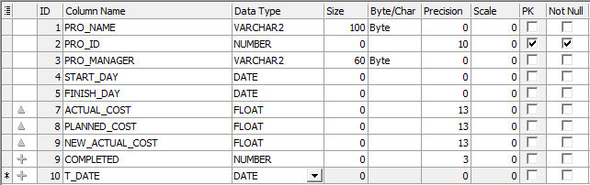

**Table 33:** Project\_information

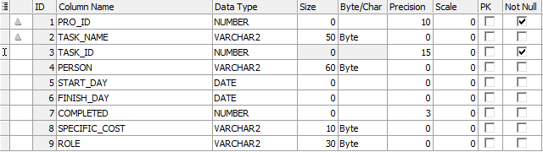

**Table 34:**Task\_information

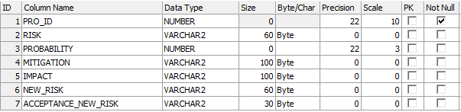

**Table 35:**Risk\_information

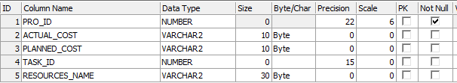

**Table 36:**Cost\_information

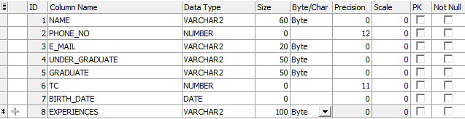

**Table 37:**Personal\_information

****

**Table 38:**Role\_information

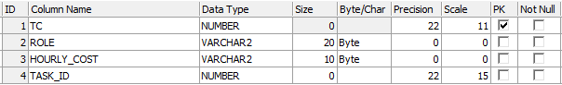

**Table 39:**Follow\_up\_hours

**RequirementsTraceability Matrix(RTM)**

**RequirementsTraceability Matrix(RTM)**

|  |  |  |  |
| --- | --- | --- | --- |
| **ID** | **REQUIREMENT** | **DESIGN SPECIFICATION** | **PROGRAM MODULE** |
| 1.1 | Admin, Project maneger and team member can login the system. | Project organization | Loginmodule |
| 2.1 | Admin can createnewproject. | Project organization | Adminmodule |
| 2.2 | Admincan assignprojectmanager. | Project organization | Adminmodule |
| 2.3 | Admin can createnewuser | Project organization | Adminmodule |
| 3.1 | Project manager can assigntask | Project plan | Taskassignmodule |
| 3.2 | Project manager can assign role | Project plan | Taskassignmodule |
| 3.3 | Project manager can enter time period | Project plan | Taskassignmodule |
| 3.4 | Team member can updatetaskinformation | Project plan | Taskassignmodule |
| 3.5 | Project manager can seeplannedcost, actualcost. | Project organization | Costmodule |
| 3.6 | Project manager can reportthecost | Project organization | Costmodule |
| 3.7 | Project manager canenternewactualcost | Project organization | Costmodule |
| 3.8 | Team member can enternewactualcost | Project organization | Costmodule |
| 3.9 | Project manager can see risk table . | Project organization | Risk module |
| 3.10 | Project manager can enterrisks. | Project organization | Risk module |
| 3.11 | Project manager can acceptorrejectthenew risk | Project organization | Risk module |
| 3.12 | Project manager can reporttherisks | Project organization | Risk module |
| 3.13 | Project manager can seeothersand his/her personalinformation. | Personalinformation | Profile module |
| 3.14 | Project manager can change his/her personalinformation. | Personalinformation | Profile module |
| 3.15 | Project manager can changepassword. | Personalinformation | Profile module |
| 3.16 | Team member can changethepassword. | Personalinformation | Profile module |
| 3.17 | Team member can see risk table. | Project organization | Risk module |
| 3.18 | Team member can enternew risk | Project organization | Risk module |
| 3.19 | Team member canseeplannedcostandactualcost. | Project organization | Costmodule |
| 3.20 | Team member can enterextracost. | Project organization | Costmodule |
| 3.21 | Team member can seeallpersonalinformation. | Personalinformaton | Profile module |
| 3.22 | Team member can change his/her personalinformation. | Personalinformaton | Profile module |

**Table 40:** RTM